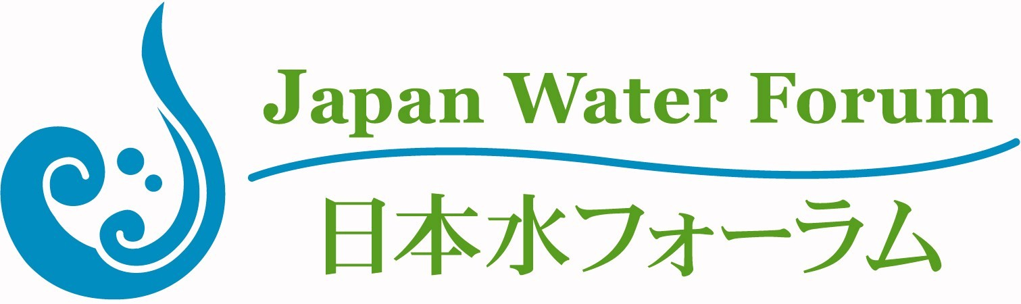
“Flood Fighting Drill Tour 2017”
Saturday, 20th May 2017

- Please kindly fill out this form ELECTRONICALLY and send it back to Japan Water Forum by E-MAIL via kato@waterforum.jp by Tuesday, 2 May, 2017.
- You can also download this form from our website (http://www.waterforum.jp/en/).
- Attendee Profile* (*The person who will join the tour)
Title: ☐Dr. ☐Prof. ☐Mr. ☐Mrs. ☐Ms. ☐Other
First Name: Last Name:
Middle Name: Date of Birth:
E-mail: Position:
- Accompanying Person(s)
Title | Name | Date of Birth (DD/MM/YYYY)
- Select -
- Select -
- Select -

- Special Dietary Requirements / Requests
- Registrant Profile* (*The person who submits this form on behalf of the attendee)
Name: Position:
Mobile Number: (contact number during the event)
Organization:
Tel: E-Mail:
Address:

